* **Install docker and docker pipeline plugins for Jenkins. Example of docker pipeline plugin below**

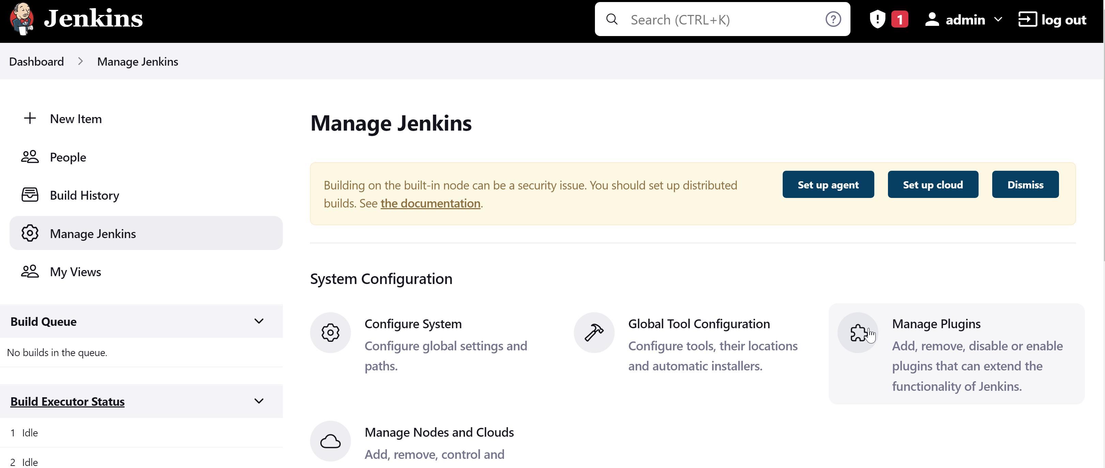

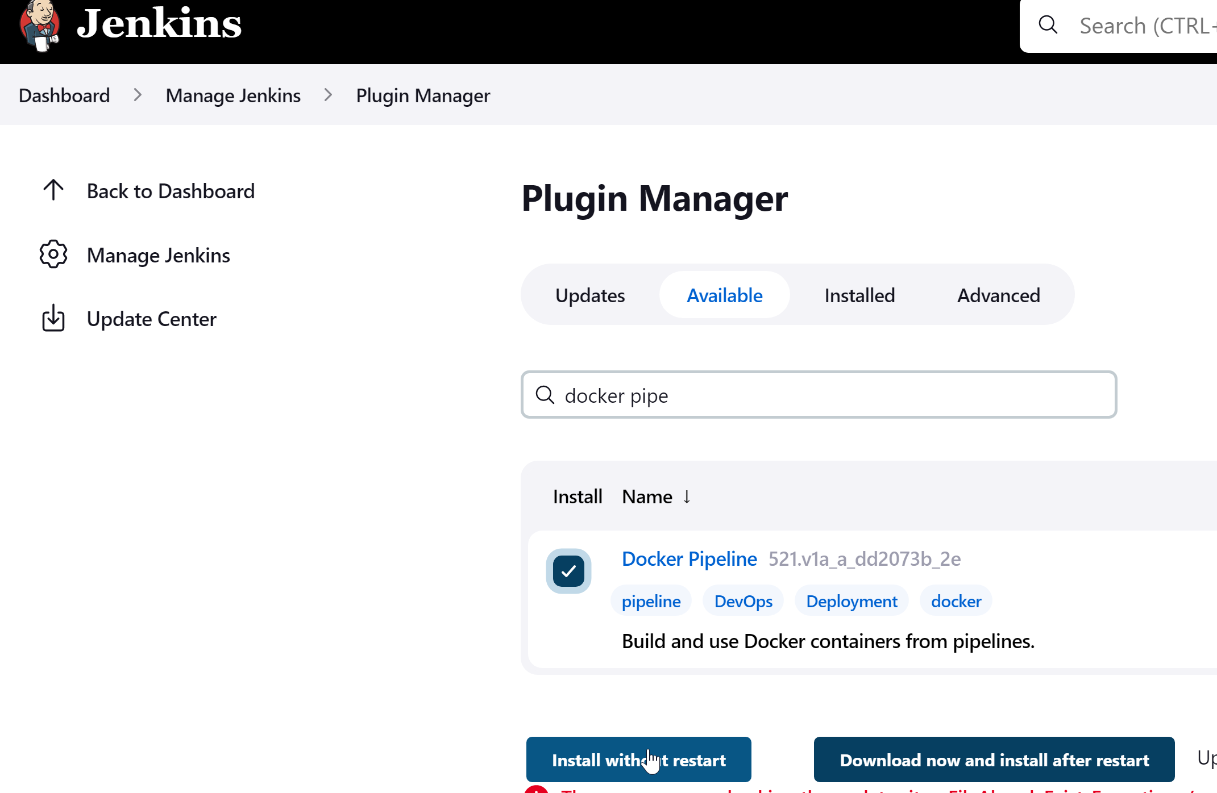

And restart Jenkins from GUI

xxxxxxxxxxxxxxxxxxxxxxxxxxxxxxxxxxxxxxxxxxxxxxxxxxxxxxxxxxxxxxxxxxxxxxxxxxxxxxxxxxxxxxxxxxxxxxxxxx

* **Configure JDK**

To find out the java path , use below

rahul@jenkins-server1:~$ sudo find /usr/lib/jvm/java-1.* | head -3

/usr/lib/jvm/java-1.11.0-openjdk-amd64

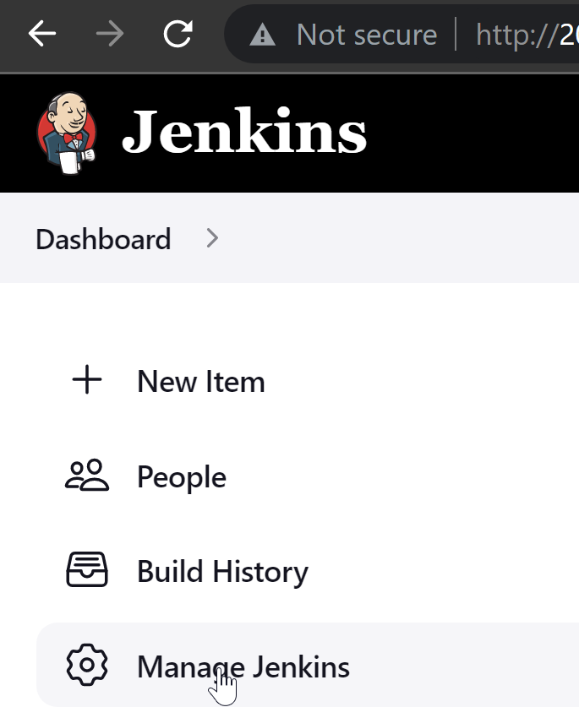

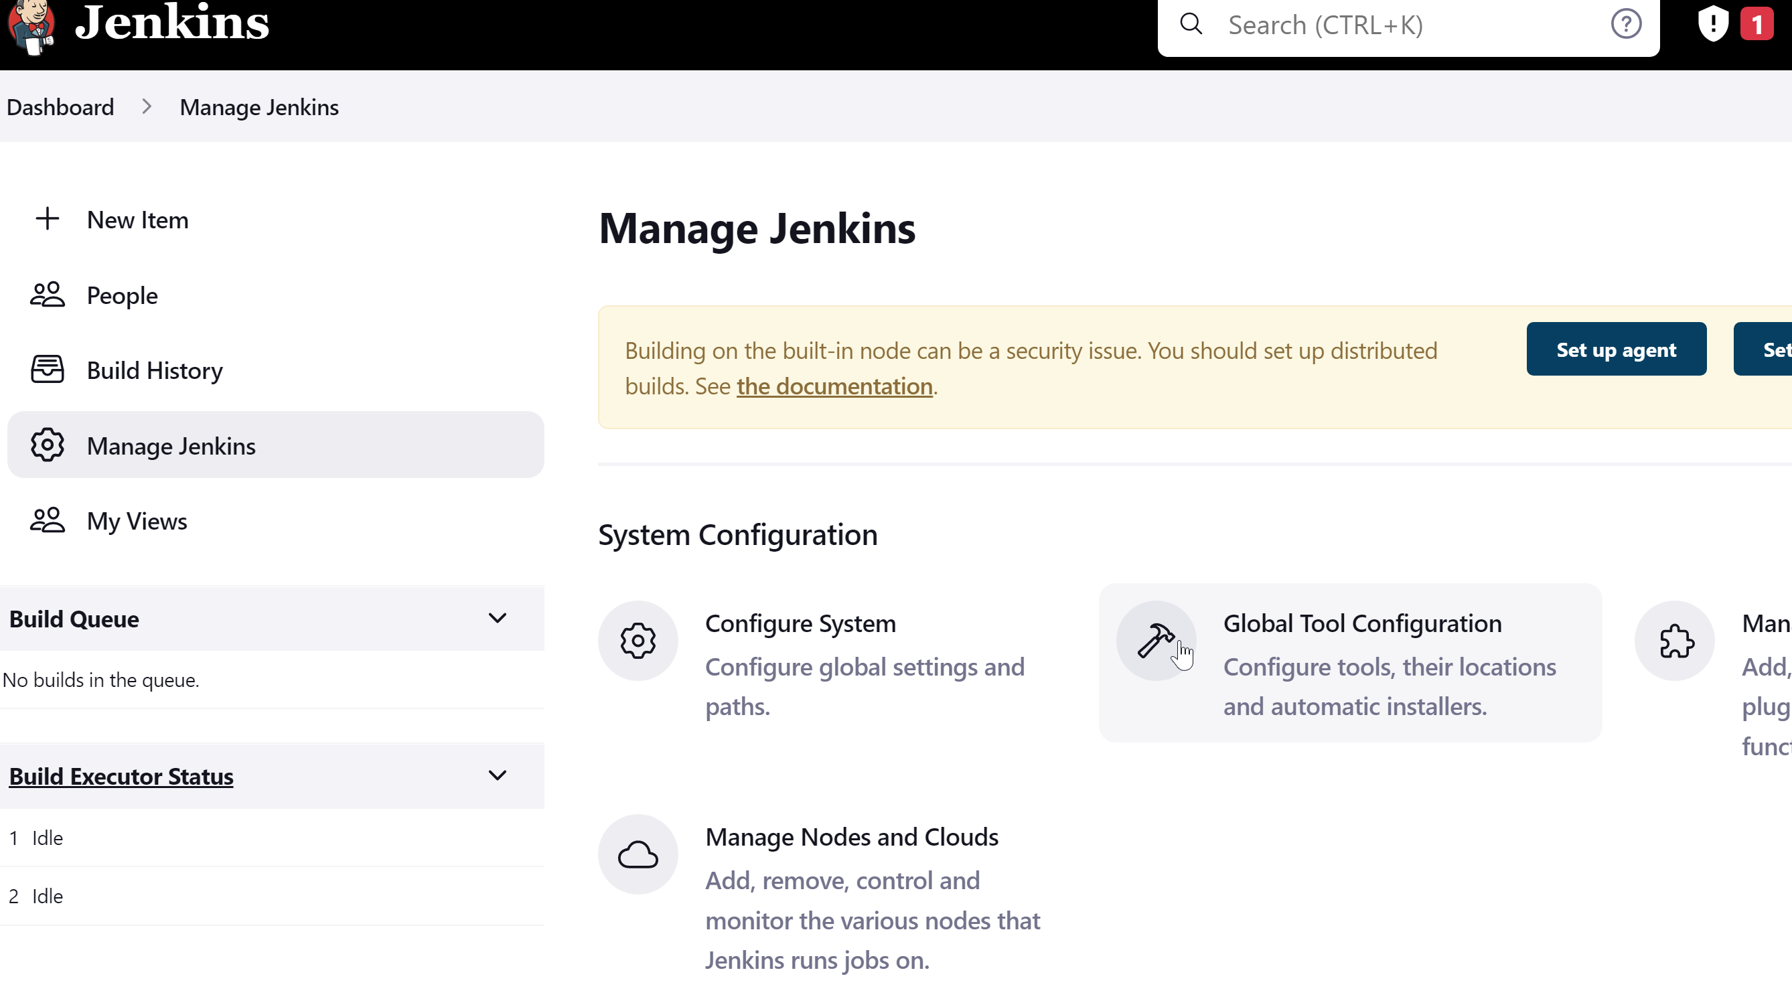

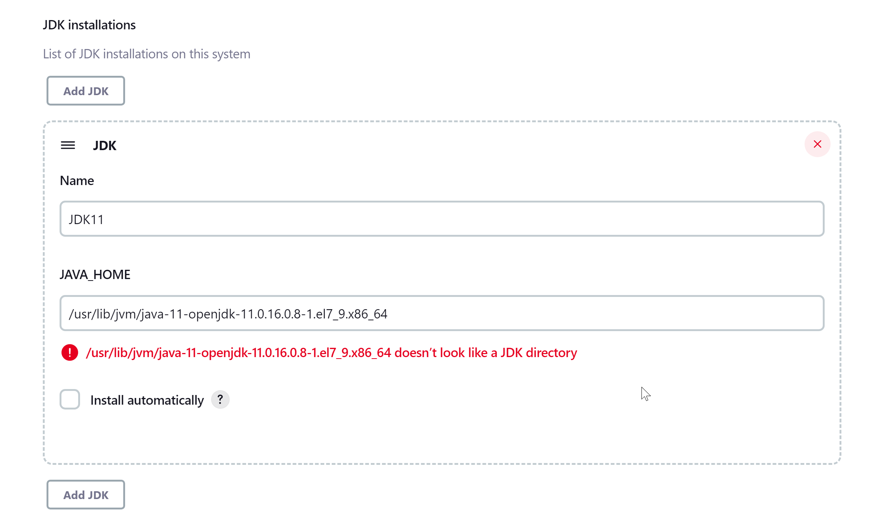

Finally click on Save

xxxxxxxxxxxxxxxxxxxxxxxxxxxxxxxxxxxxxxxxxxxxxxxxxxxxxxxxxxxxxxxxxxxxxxxxxxxxxxxxxxxxxxxxxxxxxxxxxx

* **Input ACR Credentials**

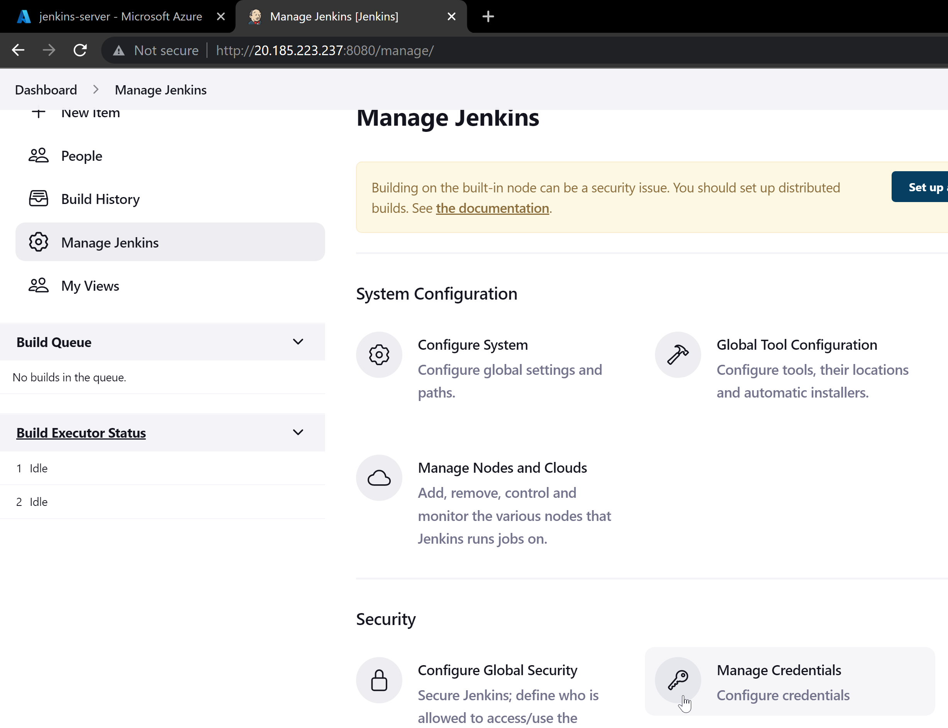

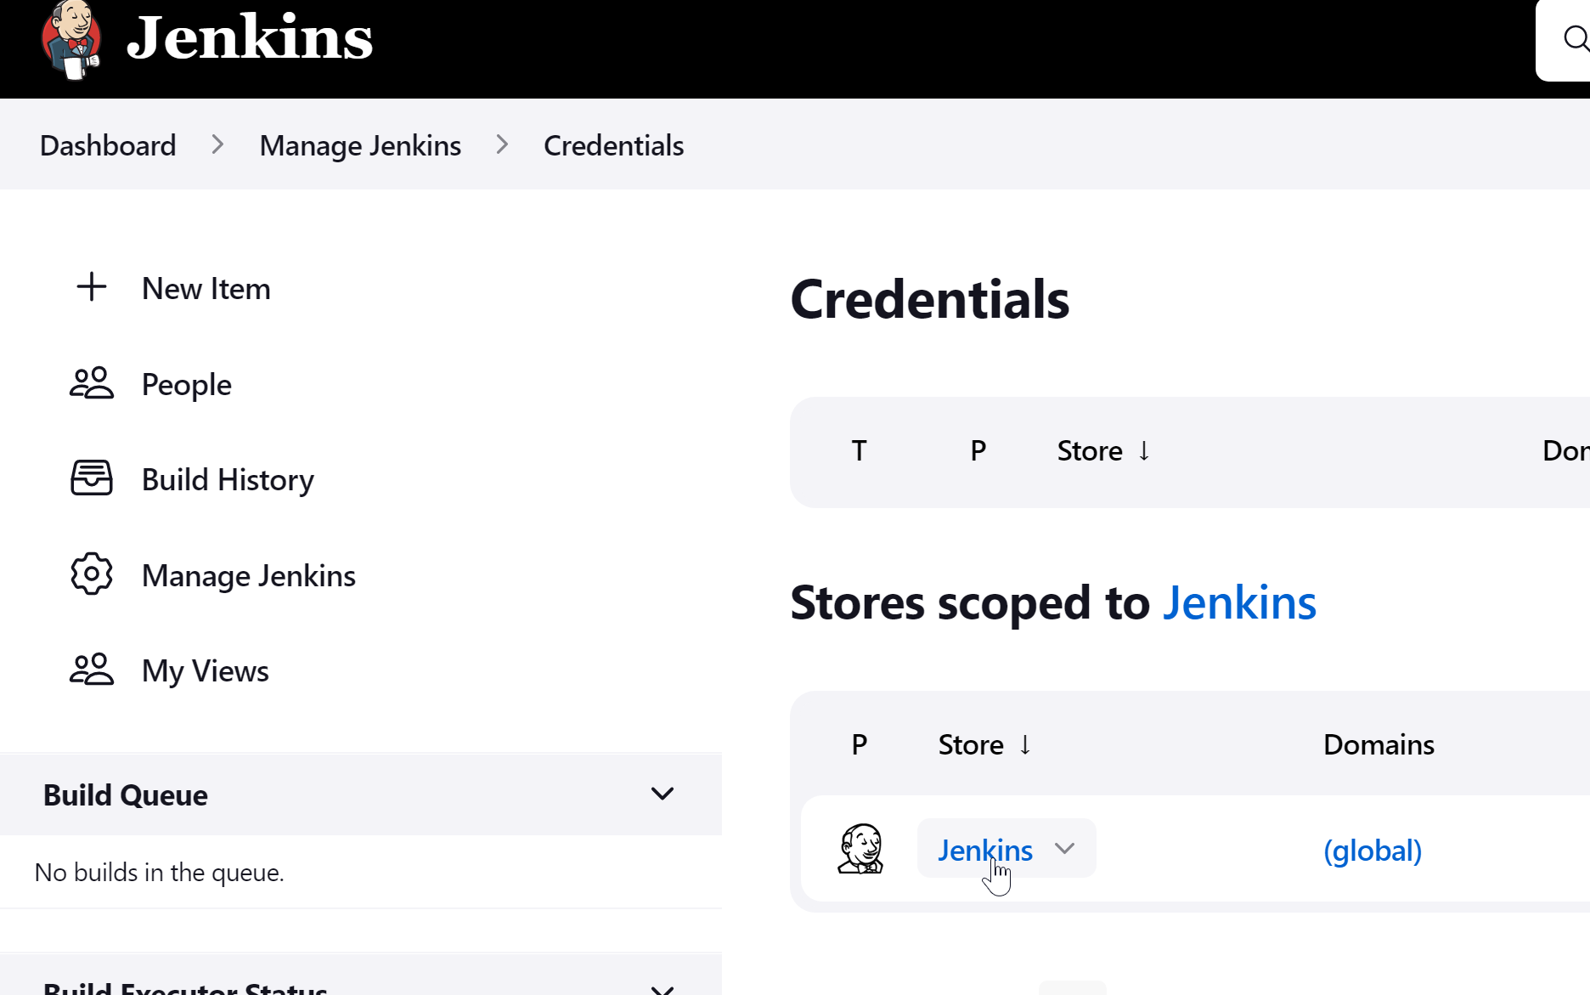

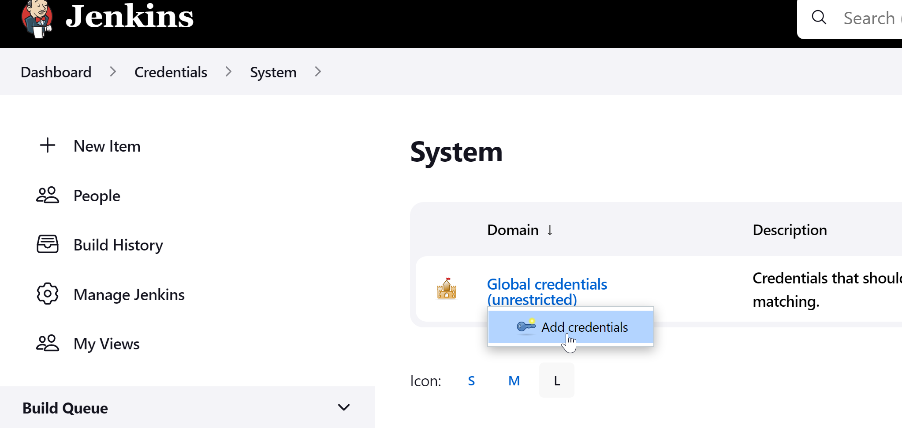

Run below to get ACR Credentials

PS C:\Users\The Cosmos\Desktop\Tech\Python-Restapi-Azure-AKS\AKS Cluster> az acr credential show --name reg0001

{

"passwords": [

{

"name": "password",

"value": "IqsfEyLWS1FF6=Bc39xk+DDU6EgIbht/"

},

{

"name": "password2",

"value": "UQXR=H2q1vmB7UxFPy0RUQCJ0z5qB7GD"

}

],

"username": "reg0001"

}

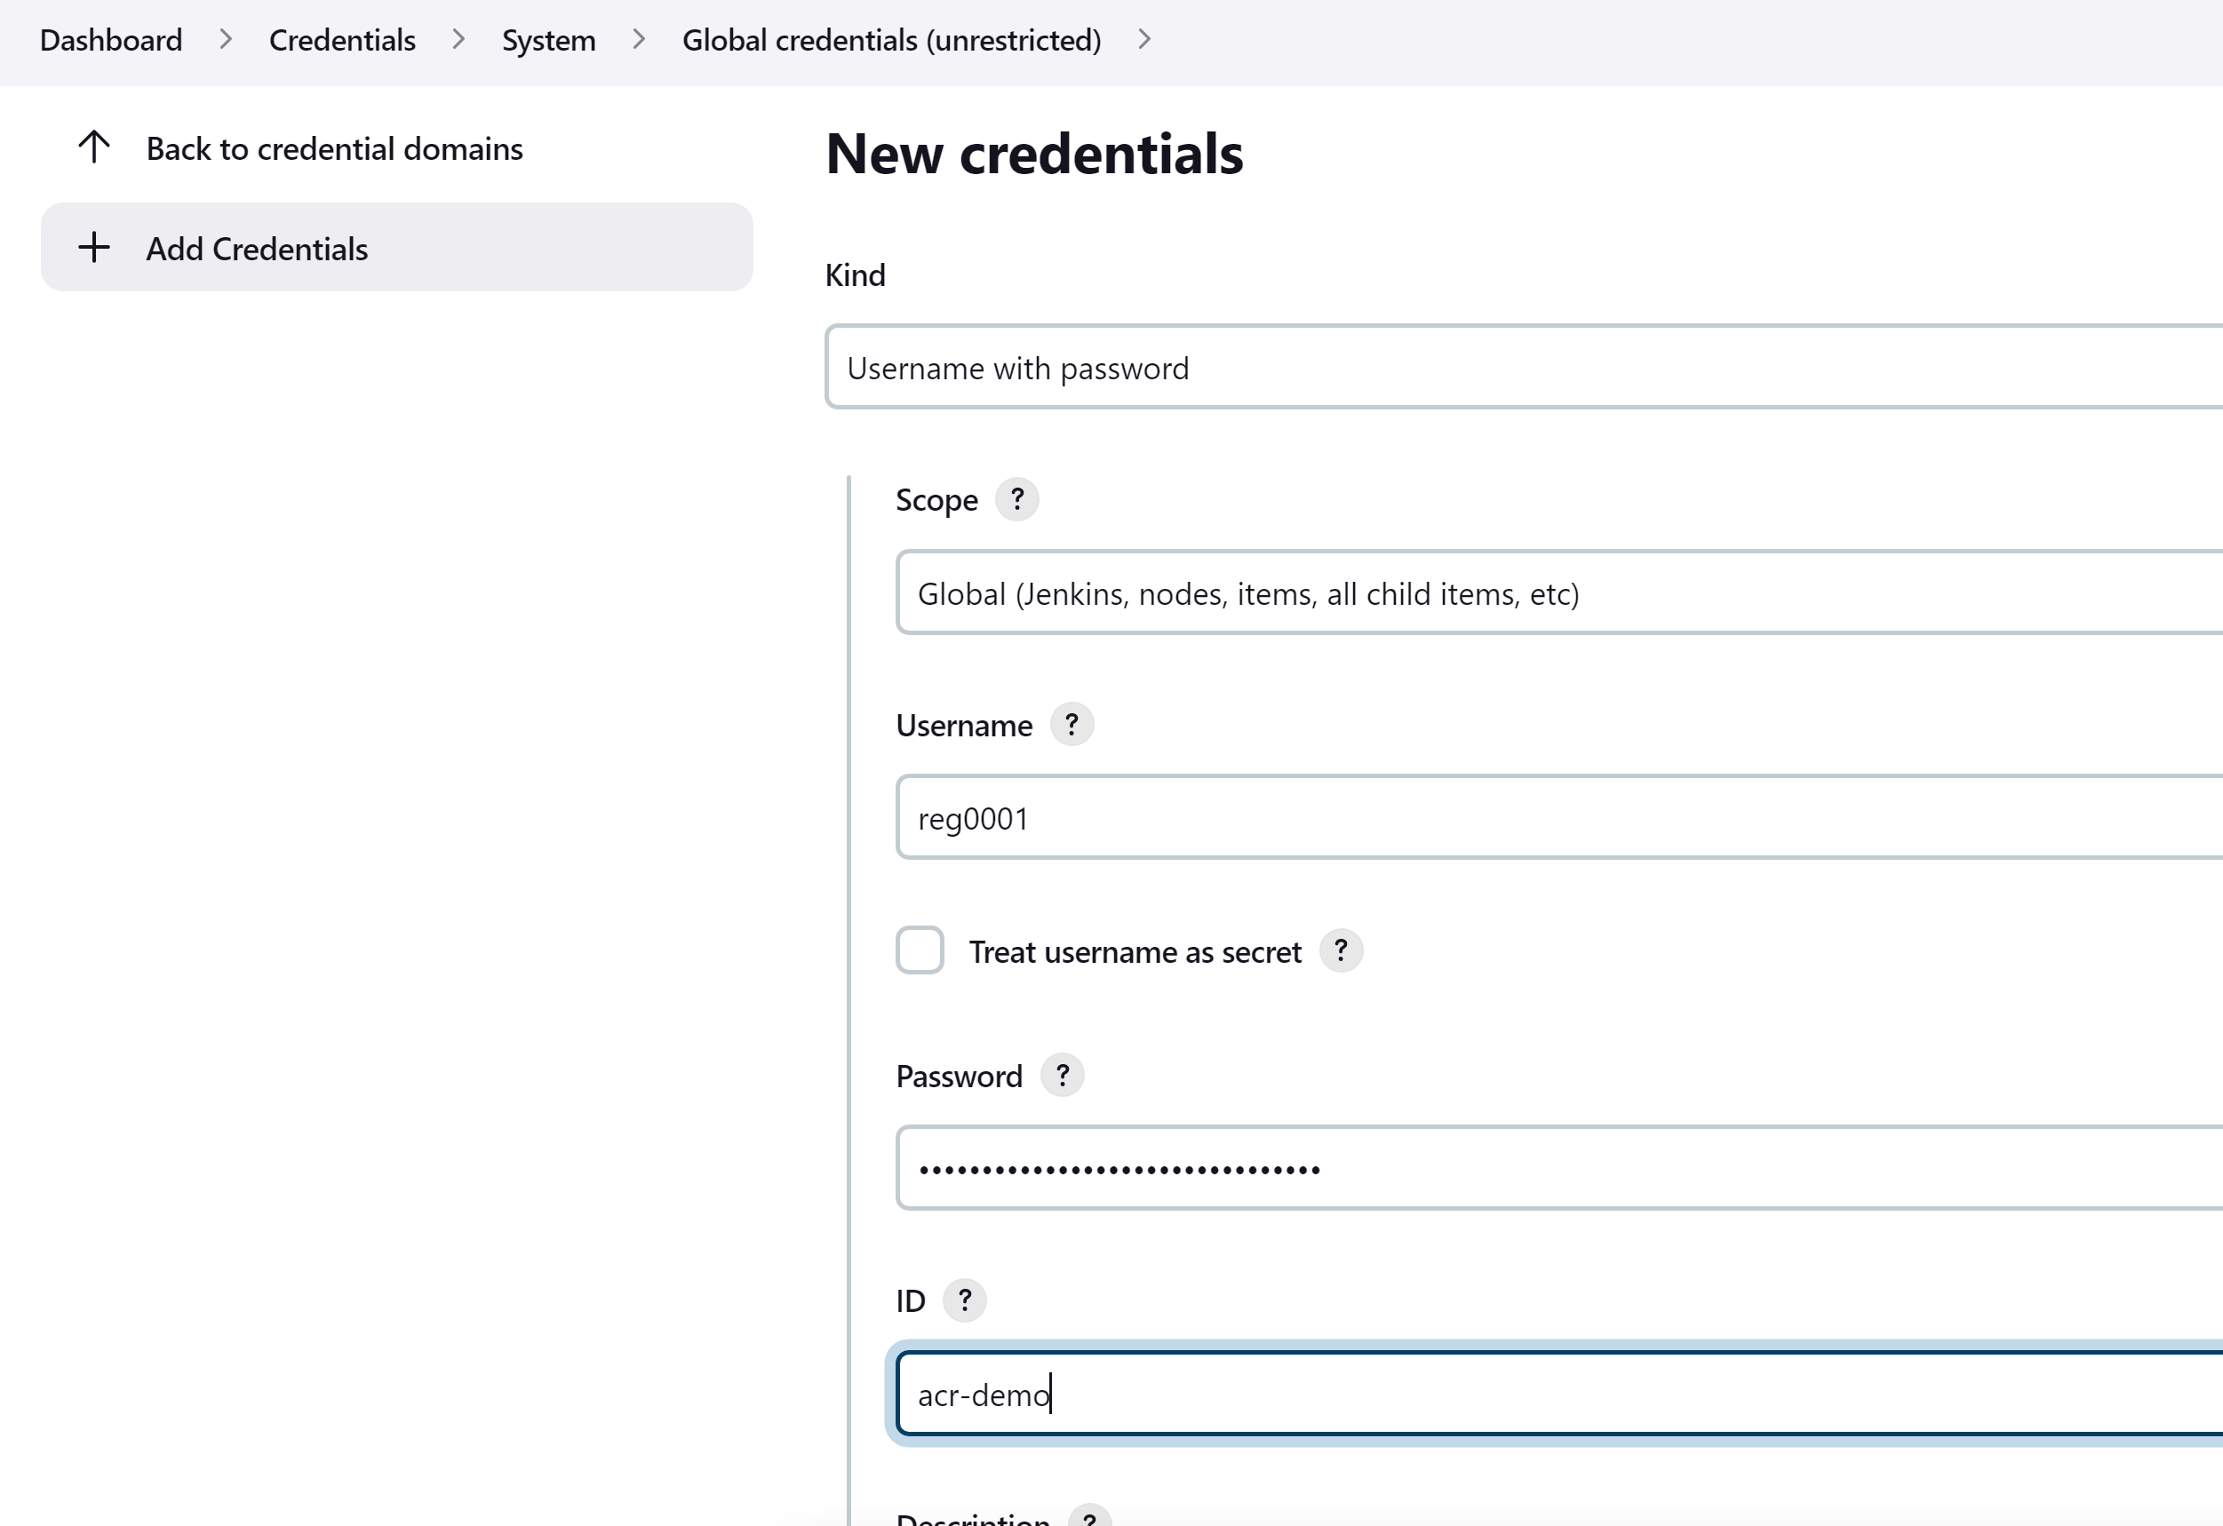

xxxxxxxxxxxxxxxxxxxxxxxxxxxxxxxxxxxxxxxxxxxxxxxxxxxxxxxxxxxxxxxxxxxxxxxxxxxxxxxxxxxxxxxxxxxxxxxxxx

* **Create the Build / CI pipeline for code checkout from GitHub, build the image and push this image to ACR**

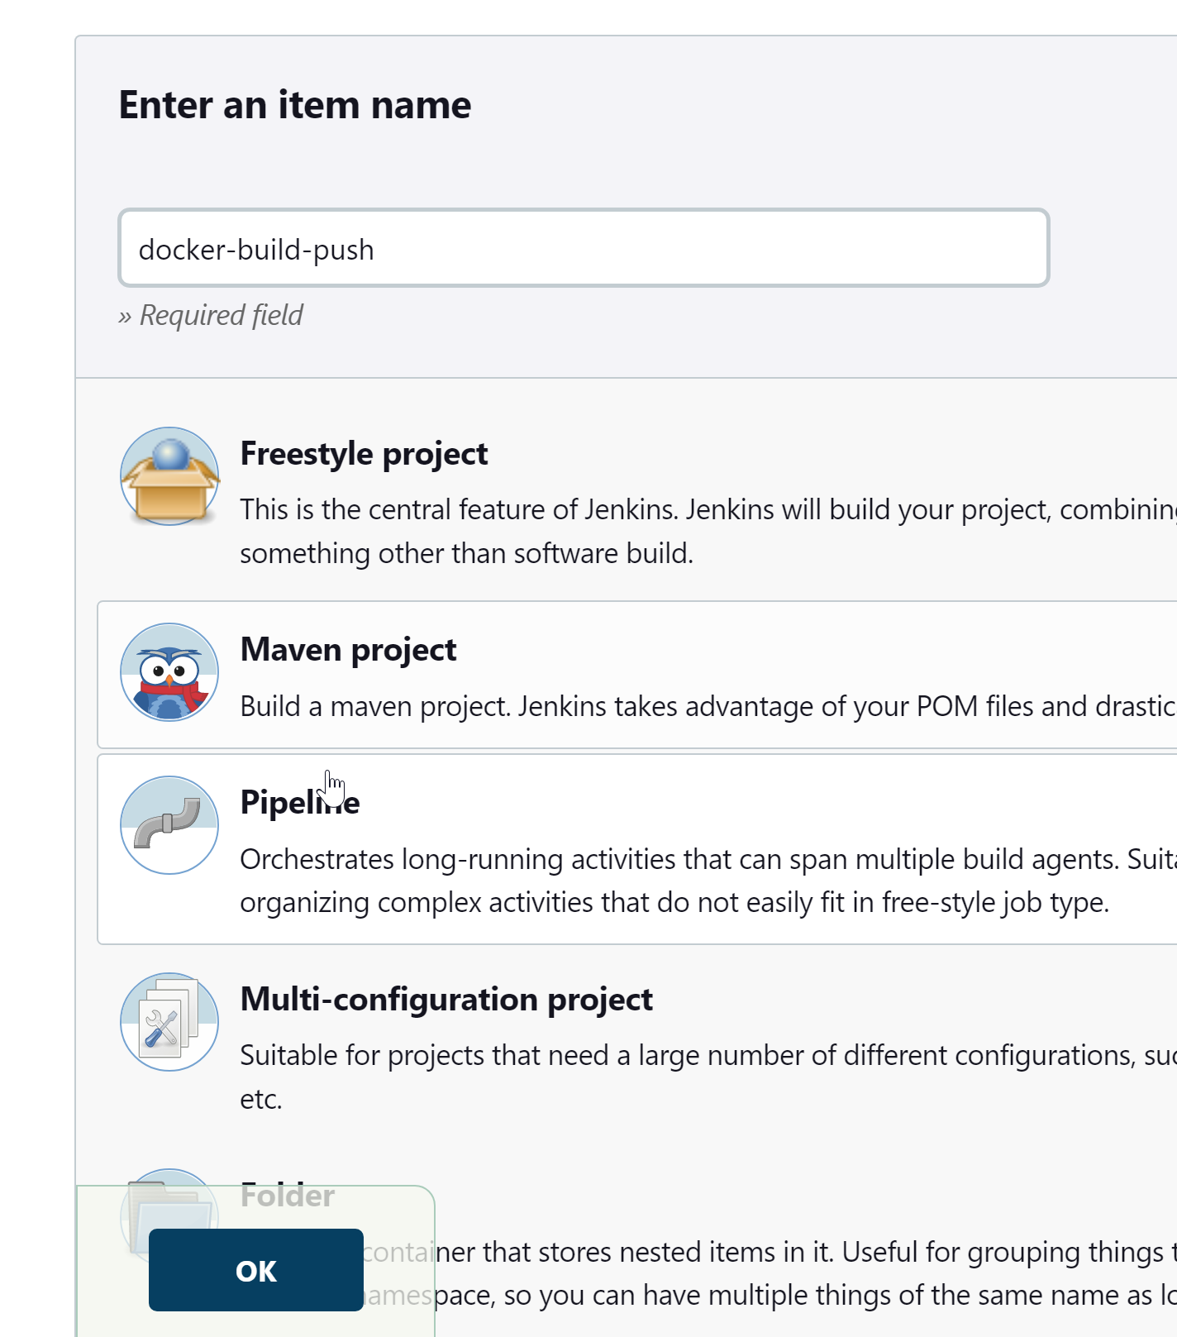

Write below declarative pipeline and Apply > Save

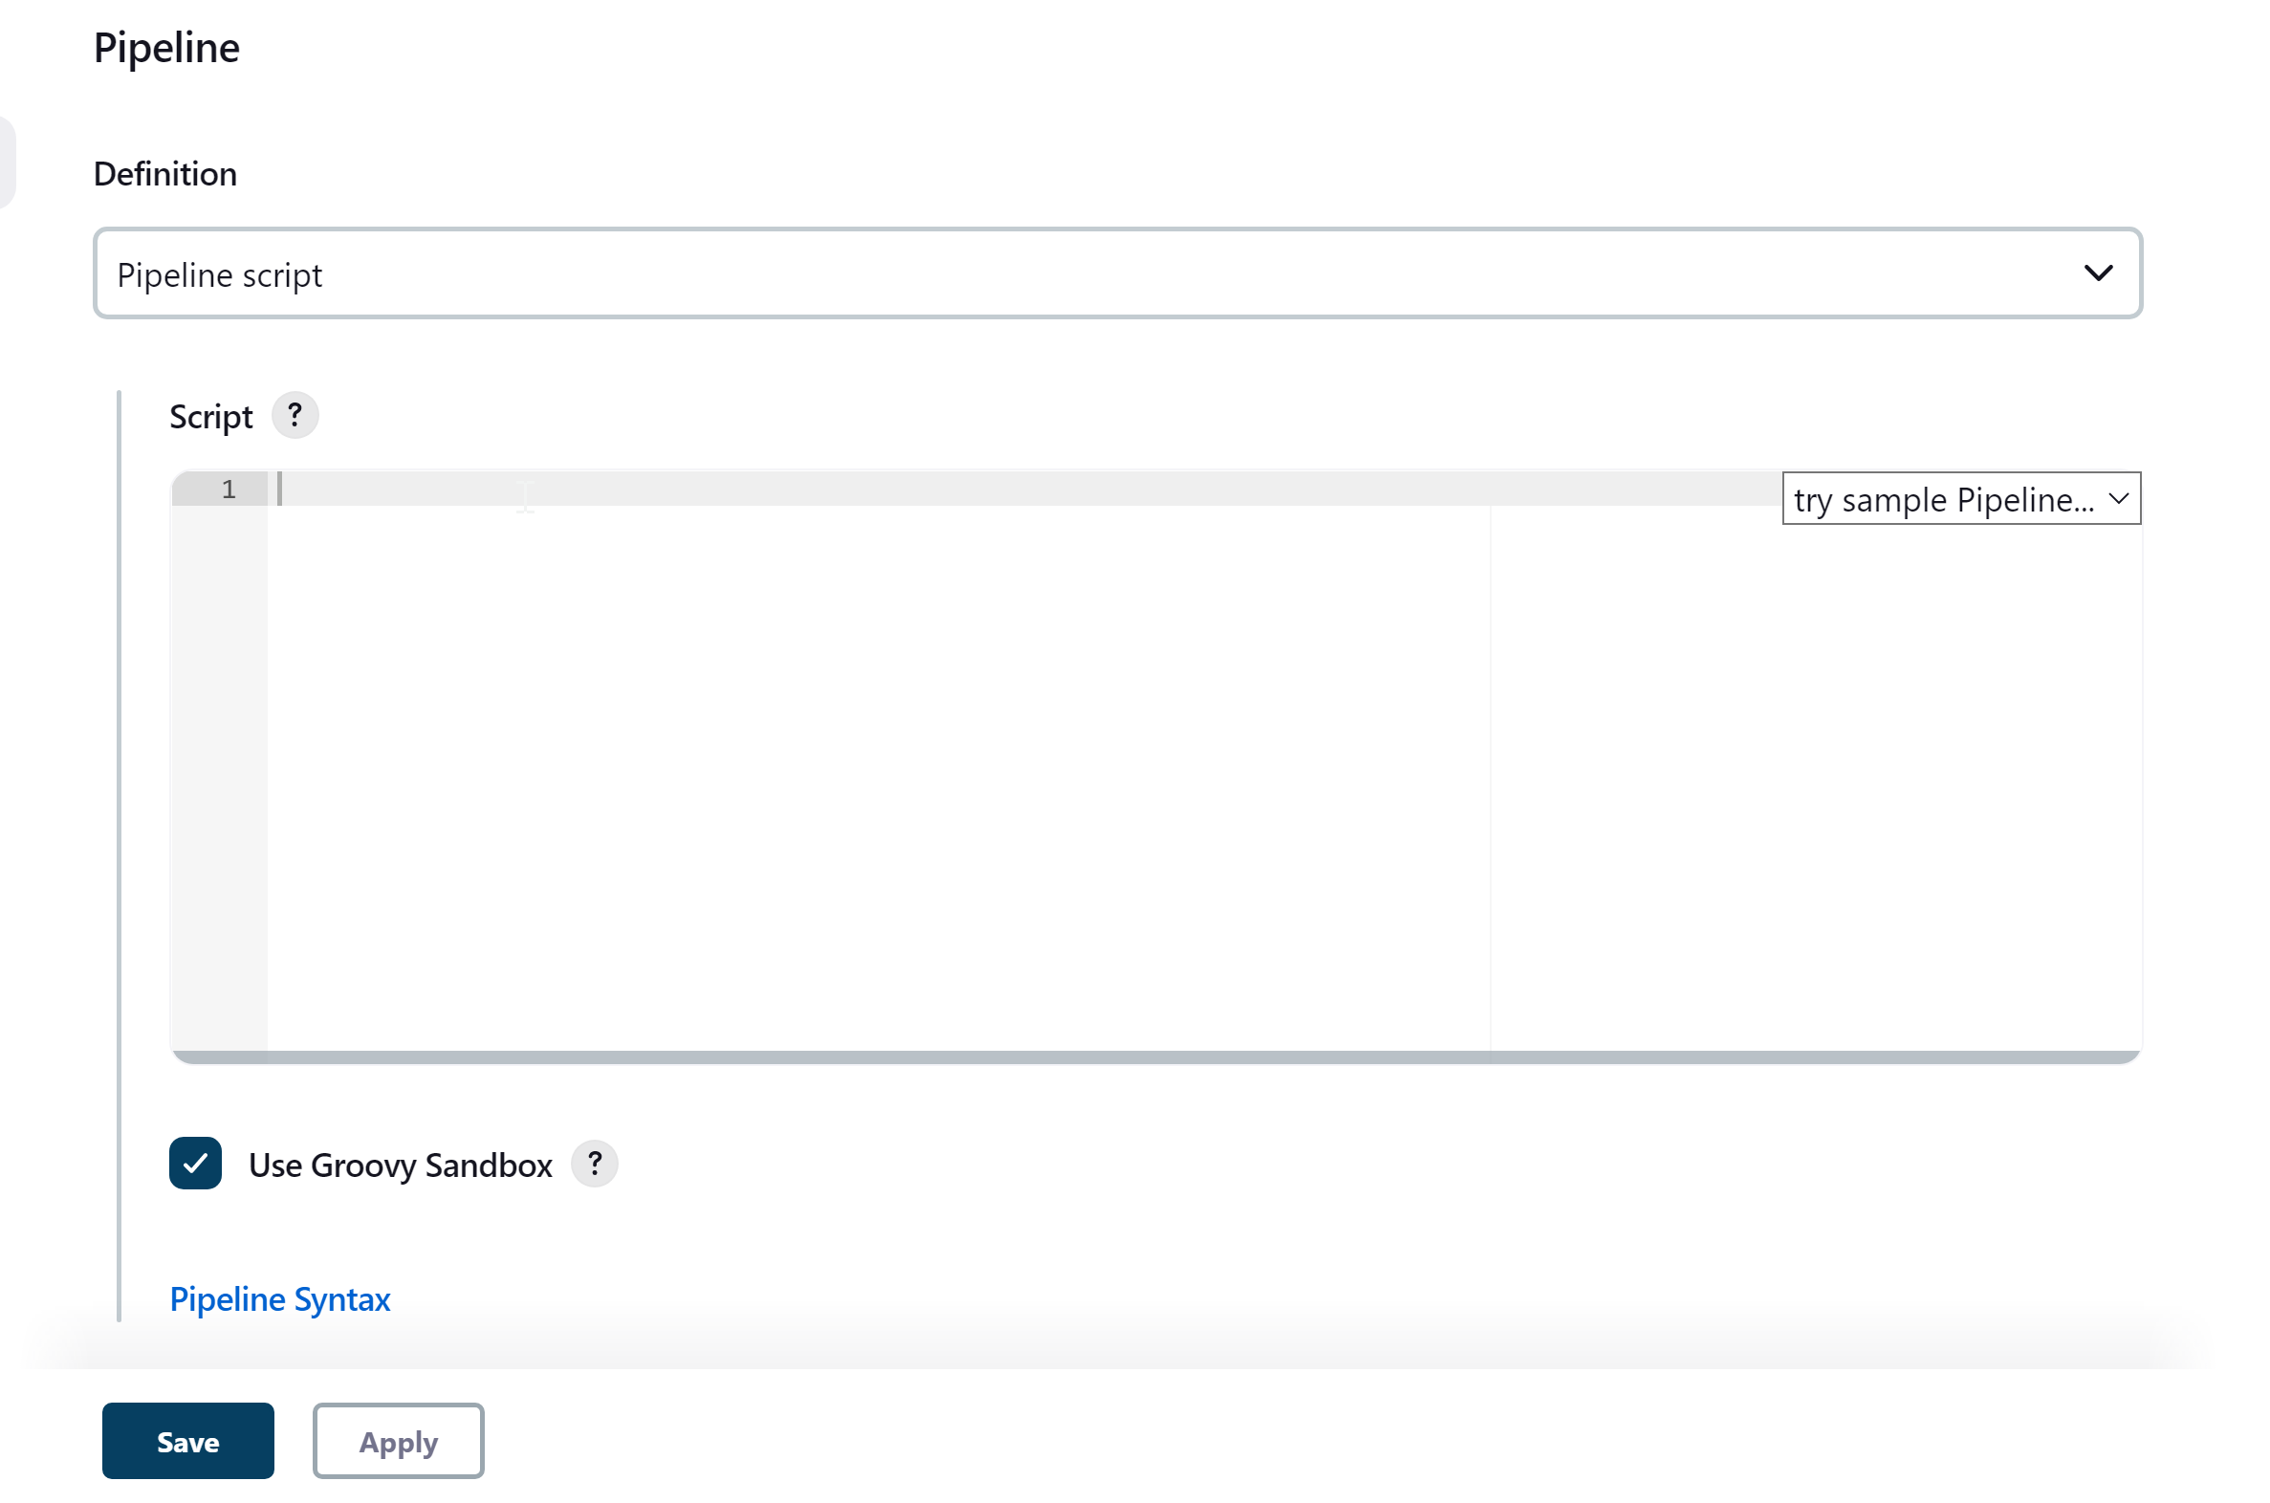

Click Apply > Save

Finally Build the Pipeline

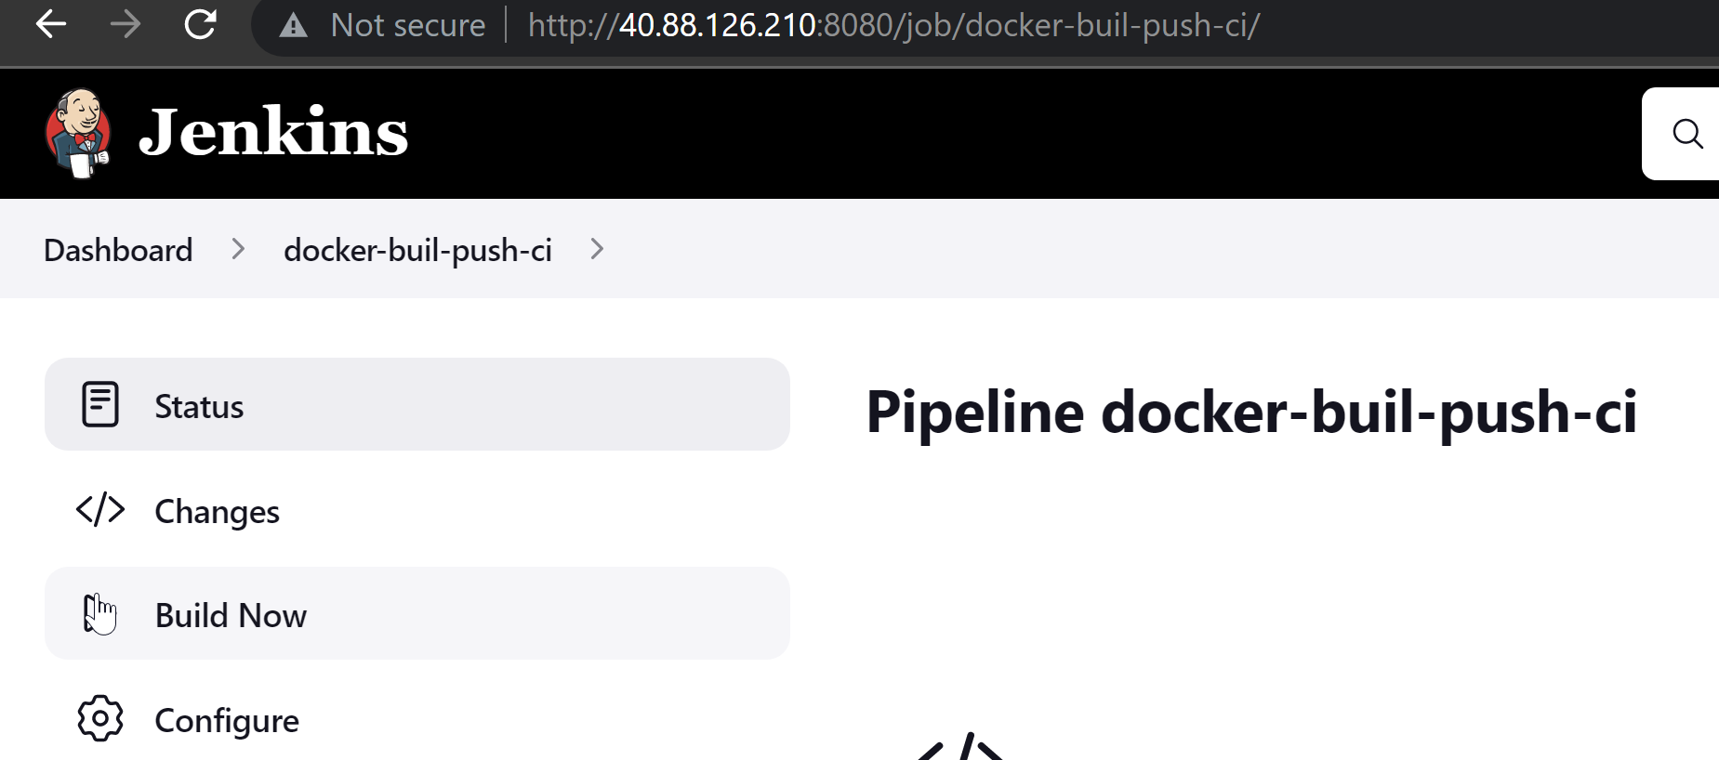

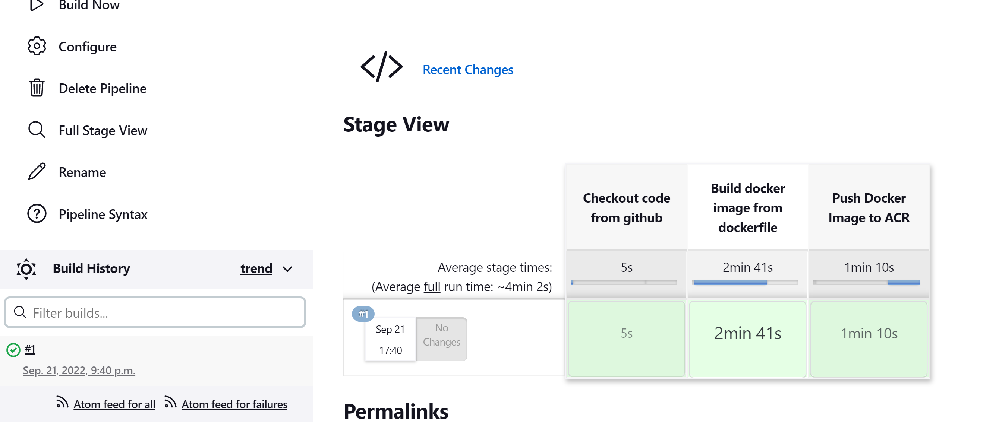

You should also see the image on Jenkins Server

rahul@jenkins-server1:~$ sudo docker images

REPOSITORY TAG IMAGE ID CREATED SIZE

reg0001 latest e2a5b61662a3 About a minute ago 933MB

reg0001.azurecr.io/reg0001 latest e2a5b61662a3 About a minute ago 933MB

python 3 e285995a3494 13 days ago 921MB 3 e285995a3494 8 days ago 921MB

And pushed to ACR

The Cosmos@TheCosmos:[~/Desktop/Tech/AKS/Code]: az acr repository list --name reg0001

[

"reg0001"

]

xxxxxxxxxxxxxxxxxxxxxxxxxxxxxxxxxxxxxxxxxxxxxxxxxxxxxxxxxxxxxxxxxxxxxxxxxxxxxxxxxxxxxxxxxxxxxxxxxx

* **Create Deploy / CD pipeline to deploy the Python-RestAPI on AKS**

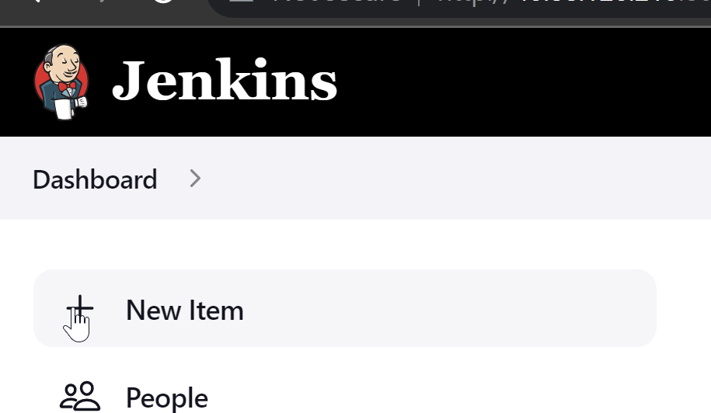

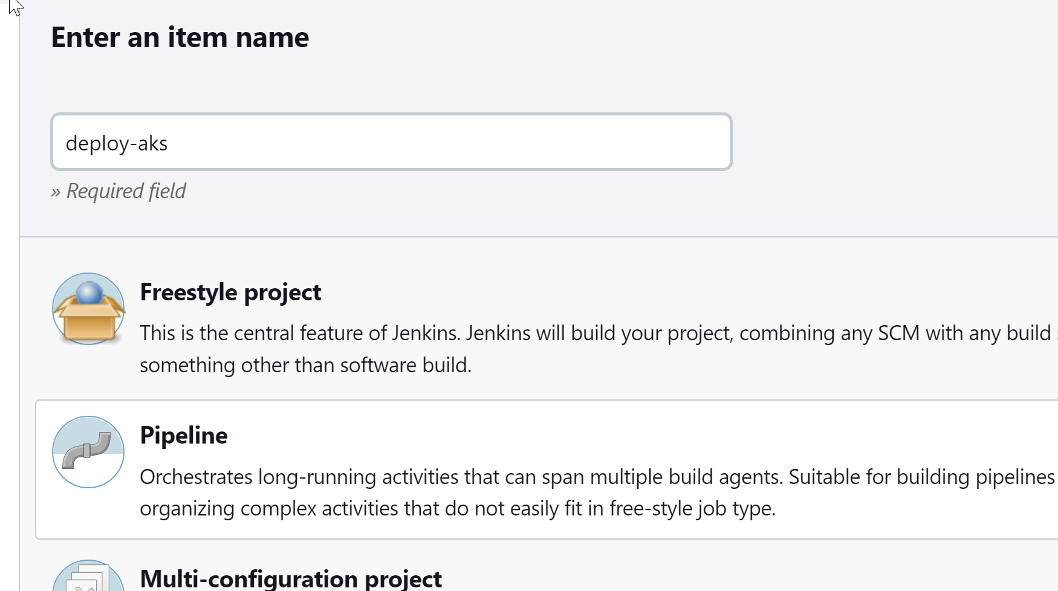

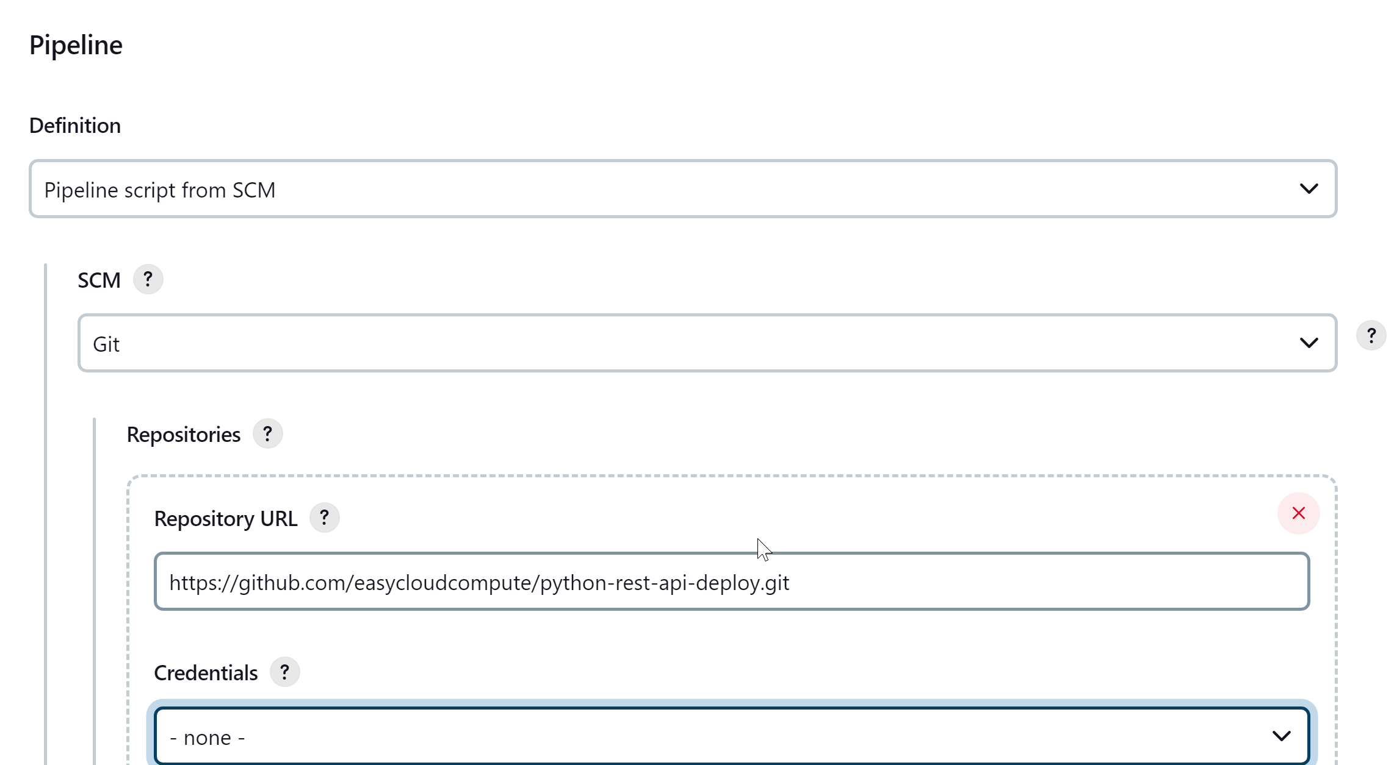

Apply > Save > Build the Job

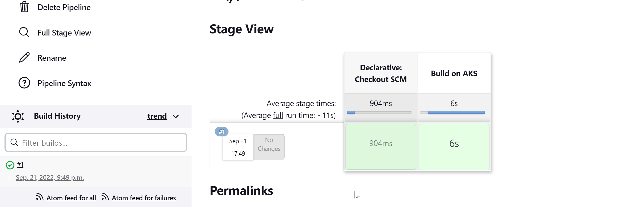

xxxxxxxxxxxxxxxxxxxxxxxxxxxxxxxxxxxxxxxxxxxxxxxxxxxxxxxxxxxxxxxxxxxxxxxxxxxxxxxxxxxxxxxxxxxxxxxxxx

Post Verification:

Before running the job:

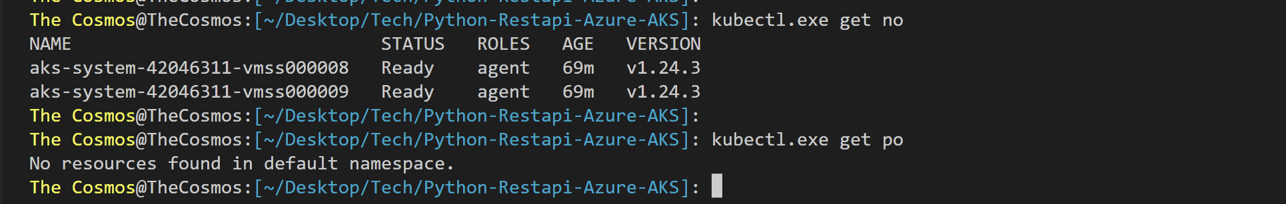

After running the job:

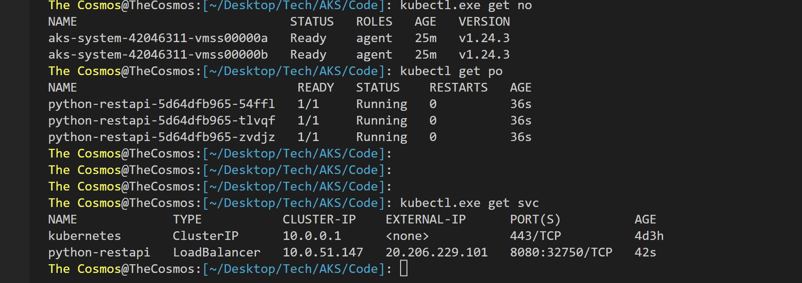



Verify Python-RestAPI is deployed fine –

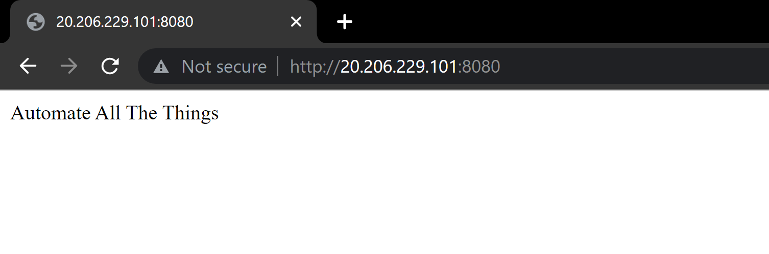

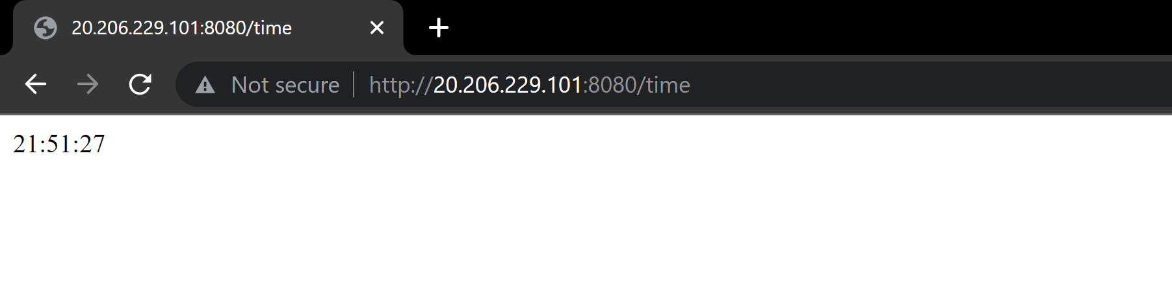

xxxxxxxxxxxxxxxxxxxxxxxxxxxxxxxxxxxxxxxxxxxxxxxxxxxxxxxxxxxxxxxxxxxxxxxxxxxxxxxxxxxxxxxxxxxxxxxxxx